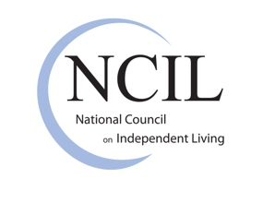
The Independent Living Advocate’s Toolkit for Mentoring Families of Children with Disabilities

Brief #9: Defining Independent Living
Independent Living does not mean that we want to do everything by ourselves, do not need anybody or like to live in isolation. Independent Living means that we demand the same choices and control in our every-day lives that our non-disabled brothers and sisters, neighbors and friends take for granted. We want to grow up in our families, go to the neighborhood school, use the same bus as our neighbors, work in jobs that are in line with our education and interests, and raise families of our own. We are profoundly ordinary people sharing the same need to feel included, recognized and loved.
~ Judy Heumann, principal founder of the disability rights movement.
Independence in practice involves interdependence, which means that family, friends, and professionals have a role in the youth’s life as they transition and for as long as they choose to have them in their life. Part of the Independent Living Planning that takes place in Centers for Independent Living involves identifying the network of support people that will help ensure successful achievement of goals. Goals change or are modified as the individual moves through the different chapters of their life and deepens their understanding of what makes them happy. They will make new friends, family members may pass away or become incapacitated, and they may choose new professionals for health care, therapies, or legal counsel. The key to independence is the right to be in control of the choices.
Setting a course for the life one chooses can involve identifying any of the following (and more) as part of the goal setting process:
- Knowledge of disability rights laws
- Accessible, affordable housing options and home modifications
- Accessible transportation
- Available financial benefits
- Skills for independent living, self-advocacy, and job search
- Supported decision making and person-centered planning
- Personal assistance and home care services
- Sign language interpretation and/or foreign language interpretation
- Skills to transition to adult healthcare and knowledgeable/supportive providers
- Durable medical equipment and assistive technology
- Alternate formats of print and online materials
Having any of these supports does not diminish the human right of the individual to have control of their own life. The support provides the means to make it possible.

https://en.wikipedia.org/wiki/Independent_living

