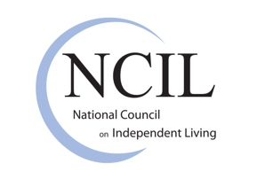
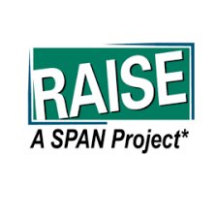
The Independent Living Advocate’s Toolkit for Mentoring Families of Children with Disabilities

Brief #5: Enabling Empowerment
Empowerment is one of the words used in the Rehabilitation Act, as amended, to define the philosophy of independent living for people with disabilities. Maximizing empowerment is one of the outcomes that Centers for Independent Living hope to achieve if they follow the IL philosophy of self-determination, equal access, and inclusion.
The concept of empowerment started in the 17th century as giving someone authority for legal purposes. It was later used by the civil rights and women’s movements to talk about increased social and political power. In the independent living movement, empowerment is simply a process of forming a relationship with power—not power over someone else but finding inner power. It is a process of moving from being someone who is acted upon by others to a place of acting on one’s own behalf. It may start with a feeling of powerlessness or victimhood and evolve into an awareness of having human rights, an inner compass, abilities, and self-worth.
The empowerment process has three general stages: (1) Children start out focusing on pleasing their parents, teachers, and other people in authority. They want to be accepted by others. The more dependent they are on others for physical, cognitive, or emotional support, the more important it can be to them to have that acceptance. (2) As they grow in maturity, they begin to understand that it’s okay to accept and please themselves, to have their own dreams and preferences. There may be tension between their wants and the others they are asserting their independence from. (3) The young adult who reaches a level of authentic empowerment understands that there is room for both self and others. Being empowered allows them to be considerate of others without giving away the power to direct their own lives.
Each level of empowerment can be greatly facilitated by families who early on give the disabled child choices according to their level of maturity. Allowing young people with disabilities opportunities to explore, participate, and try new things strengthens their future self-awareness and empowerment. This provides them with essential skills they will need to transition to adulthood. At first, decisions may be as minor as what clothes to put on and, later, as life changing as how to direct their own IEP and then where and how they want to live after they transition to post-secondary education, employment, or independent living.
RAISE’s Youth Development Toolkit was created as a resource for Parent Center professionals who are engaging youth on a regular basis and want to take the next step in supporting youth empowerment at the highest levels. The toolkit has several modules which contain tips and strategies that can easily be adapted by Centers for Independent Living and other organizations that work with youth with disabilities. A good place to start is with the Youth Needs Assessment Toolkit. Next, the Youth Engagement Toolkit series includes several toolkits: The Foundations of Youth Engagement and Parent Centers, Youth Development, Youth Leadership, Youth Individual Empowerment, and Youth Collective Empowerment; and a number of tip sheets and links to webinars.

