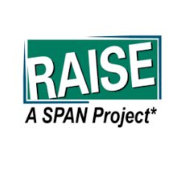
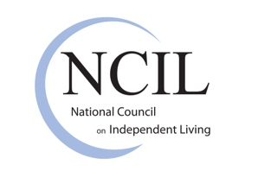
The Independent Living Advocate’s Toolkit for Mentoring Families of Children with Disabilities

Brief #3: Overview of the Parent-Led Movement
The history of how people with disabilities have been viewed and treated by society is long and harrowing. After centuries of inhumane treatment, US reformers in the 19th century began to establish institutions to provide safe housing and care. Unfortunately, the attitudes of society did not change accordingly and up until the 1940s, people with disabilities were still treated as undesirables who should be bred out of society. Institutions were dehumanizing and often abusive, and support for families and services beyond institutional warehousing was practically non-existent.
In the late 1940s and early 1950s, parents had had enough and began to organize a nationwide movement. In 1950, the first national conference was held in Minneapolis with featured speaker Governor Luther Youngdahl who declared that children with disabilities have the same rights that children everywhere have.
By the 1960s, enough families had come out of the closet of society-imposed shame to challenge the belief that people with disabilities couldn’t be helped. They began to have an impact on conditions in state institutions, increase the availability of community services, education and employment opportunities, and change legislation. The work of parent organizations to file lawsuits and get laws passed and services established contributed to the national movement to close public institutions and increase options for community living.
This momentum led to the creation of more and more organizations and associations, started by families, to address the specific needs of their children. Intellectual/developmental disabilities, cerebral palsy, muscular dystrophy, spina bifida, and various conditions were pushed into the public consciousness through the determination of families.
Today, there is a nationwide network of parent training and information centers that provide parents, families, individuals, and service providers with the information and resources they need to increase their capacity to serve youth and young adults with disabilities and their families. Although family organizations and Centers for Independent Living have different approaches, over time they have found more common ground and ways to dovetail their advocacy and resources. These collaborations have grown out of a recognition that young people, families, schools, community organizations, and government agencies must all be involved in preparing youth to transition effectively to post-secondary education, employment, and independent living.
The role and impact of families can never be diminished because the degree of self-acceptance and self-determination youth have will be rooted in their family experiences. Helping the whole family to expand its knowledge and build on its strengths can help ensure that students with disabilities can achieve their life goals.

