Creating Readable Print Materials
Before we used computers, printers, and graphic designers, we published all written documents according to specific guidelines. This was called “Typography - the art and technique of arranging type to make written language legible, readable and appealing when displayed.”
Now that we create our own print materials, we need to learn the rules that will make text readable for everyone, including people with reading, language, or visual disabilities and their families. Two key “rules” involve the readability and legibility of text.
Readability refers to the ease with which larger chunks of print can be read and understood. Readability includes the size and style of the type, the alignment of sentences, contrast and color, line length and the organization of the text. It also includes grammar, vocabulary, sentence structure, and using plain language - not jargon or acronyms. Most articles should be written to increase readability.
Legibility addresses the reader’s ability to recognize each letter. It includes the visual design and format of print materials to promote speed and clarity. Legibility refers to understanding what the characters are, not what they mean. Key factors in legibility are: letter width and height; how letters are formed;spacing between characters, words, and paragraphs; and font. Most headlines, titles and headers are written to increase legibility and to lead the reader through the
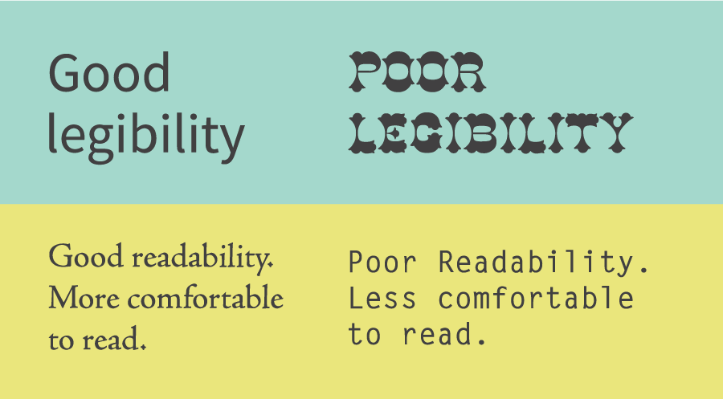
rest of the information.
While readability refers to an overall reading experience, if one cannot recognize individual characters in the text, the font is not legible. Effective use of computers to develop print materials depends on an understanding of BOTH legibility factors.
Hoffman, R. & Mayer, M. (2018). RealScientists@realscientists.

The following guidelines will help you write readable and legible print materials. The Typography: Creating Readable Text presentation on the RAISE website provides more detailed information and visual examples.
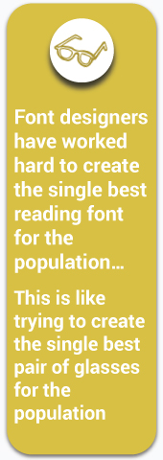
- Typeface/Fonts – A typeface is a collection of characters within a font family, such as Arial, Georgia, Helvetica, or Times New Roman. Fonts fall into two primary groups: Serif (with feet) and Sans-serif (without feet). Serifs improve the readability and legibility of large bodies of text, such as books or newspapers, by helping to guide the reader’s eyes across the page. Sans-serif fonts tend to stand out, are more easily recognized, and are better used for small chunks of text to grab your attention, such as titles and headers.
Research reports that there is no single “best” font. People prefer to read fonts they see most often – usually a serif font, such as Times New Roman. Individuals with visual impairments prefer sans-serif fonts like Arial. Fonts to avoid include novelty fonts, such as Comic Sans or Jokerman or script fonts.
Provide the ability for individuals to modify print in a Word document or online, using computer modifications or text to speech technology. This allows each person to change the format of the text or background to meet individual reading needs.
Readability Matters
Use only one font in the body of any single document. For variety, use different fonts within one family instead. Titles and headers may be in a complementary font (e.g., Cambria/Calibri). Avoid using use two serif or two sans-serif fonts in the same material.
Each new font introduces an additional task that your brain and eyes have to deal with in order to read and understand the print material.
- Letter & Word Spacing – Font weight and shape also needs to be considered. Letters that look the same can be hard to read (e.g., “l” and “I” vs. “l” and “I”). Letters that are too thick or too thin may not have enough space between them to distinguish what they are. Additionally, avoid short, fat fonts. Choose fonts that are taller, so the words do not blur together.
- Font Point Size – Text that is too large is equally difficult to read as text that is too small. Use a 10–14-point font for most print materials. Persons with visual impairments prefer a 16–18-point font but a minimum of 14. Larger font size should be used for presentations (minimum of 24-point font) and for website text (typically 12–14-point font).
- Type Case & Style – Avoid using all capital letters except for BRIEF emphasis. Instead, use upper- and lower-case letters. Style refers to bold, italics, and underlining. Do not use any of these styles too often − only to highlight key points.
- Line Length & Spacing – Keep lines and sentences short (60-80 characters and 8-10 words) so the reader’s eyes do not get tired. Space between lines in a paragraph (also known as leading) also affects the readability of text. Use line spacing between 1.0 and 1.5.
Most computer fonts are “proportionally” spaced, meaning that the space around the letters is automatically adjusted (“y” has more space than an “i”). Therefore, it is unnecessary to add more space, such as two spaces, after periods, semi-colons, or colons ( : ). Typewriters use “monospacing”, which is the same space around all characters. There are a few fonts, such as Courier New,that still use monospacing, but this should be avoided for print text.
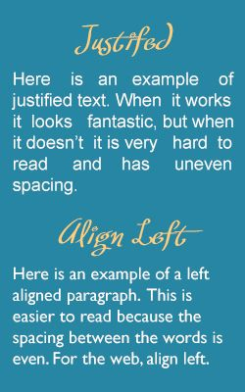
- Alignment/Justification – The text in this article is flush left or “ragged-right.” For ease of tracking with your eyes, all text should be “left-justified.” Print materials that are aligned to the right, centered, or justified with even margins (like a newspaper column) are more difficult for the reader’s eyes to track and should not be used often.
- Margins & Page Spacing – Space is the most important but overlooked aspect of text development. Space should go from the smallest space (between letters, words, lines, and paragraphs) to larger spaces (between columns, sections and the space from the text to the edge of the page). Page margins are especially important to give the eye a chance to rest when reading.
Justify or Not to Justify?
- Contrast & Color – Make sure there is enough color contrast between the text and the background to make it easy to read.
  - Black text on a white background is preferred; alternatively, use white/yellow text on a black/dark blue background.
  - Avoid words or images behind text or graduated color. The background will make the text hard to read. Use white or light-colored paper when printing documents. Do NOT use dark or neon colored paper.
  - Do not use colored type (especially red or orange) for emphasis. Use dark blue, purple, or green instead. Colored type is difficult for many people to read, including individuals with low vision or who are color blind.
  - Keep colored type to a minimum. Never refer to an item in the text only by color. Always include a visual tag along with the color description: “In the line graph showing our enrollment information across age groups, the 2021 data is represented by blue stars and the 2020 data by green squares.”
References and additional Resources can be found in the Typography: Creating Readable Text presentation on the RAISE website.

